BET9JA AGENT DETAILS FOR
MICHAEL OKA
1. AGENCY FORM: Already submitted online
2. PHOTOS OF SHOP
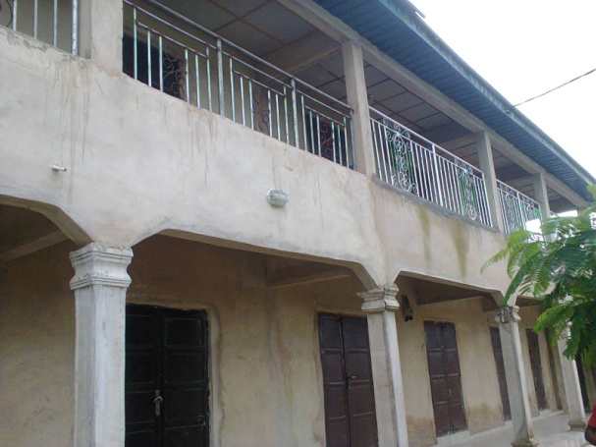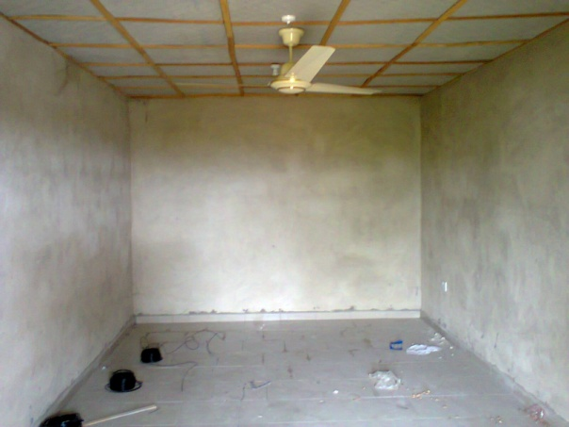

3. ID: International Passport

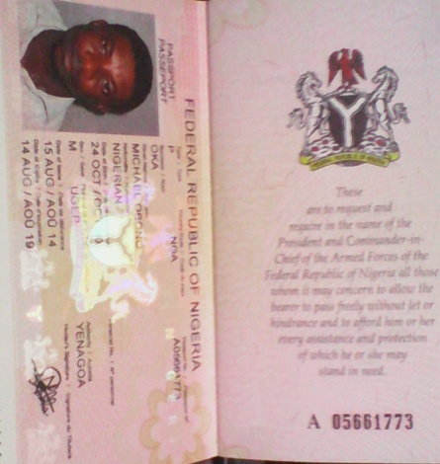
4. NAME: MICHAEL OKA
5. EMAIL: okamichaelo@gmail.com
6. TEL: +2348103487086
7. DATE OF BIRTH: 24/10/80
8. GENDER: Male
9. ADDRESS: 21 Adim Road, Idomi, Yakurr LGA Cross River State

